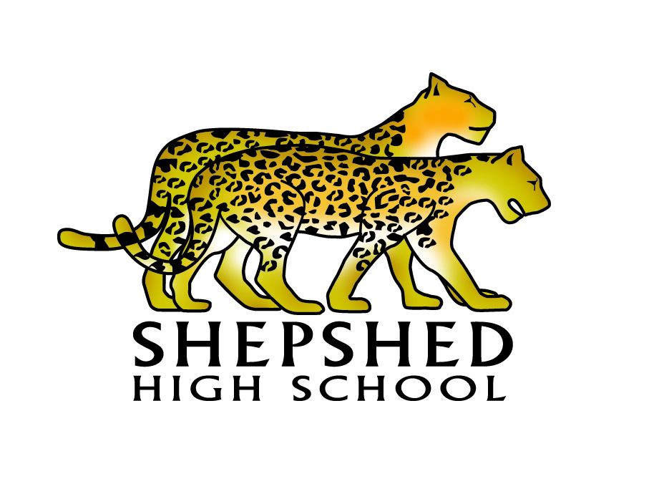
Hello and welcome to Shepshed High School. Our school logo consists of two leopards, because our old school used to have a sculpture of two leopards on the outside of the building.

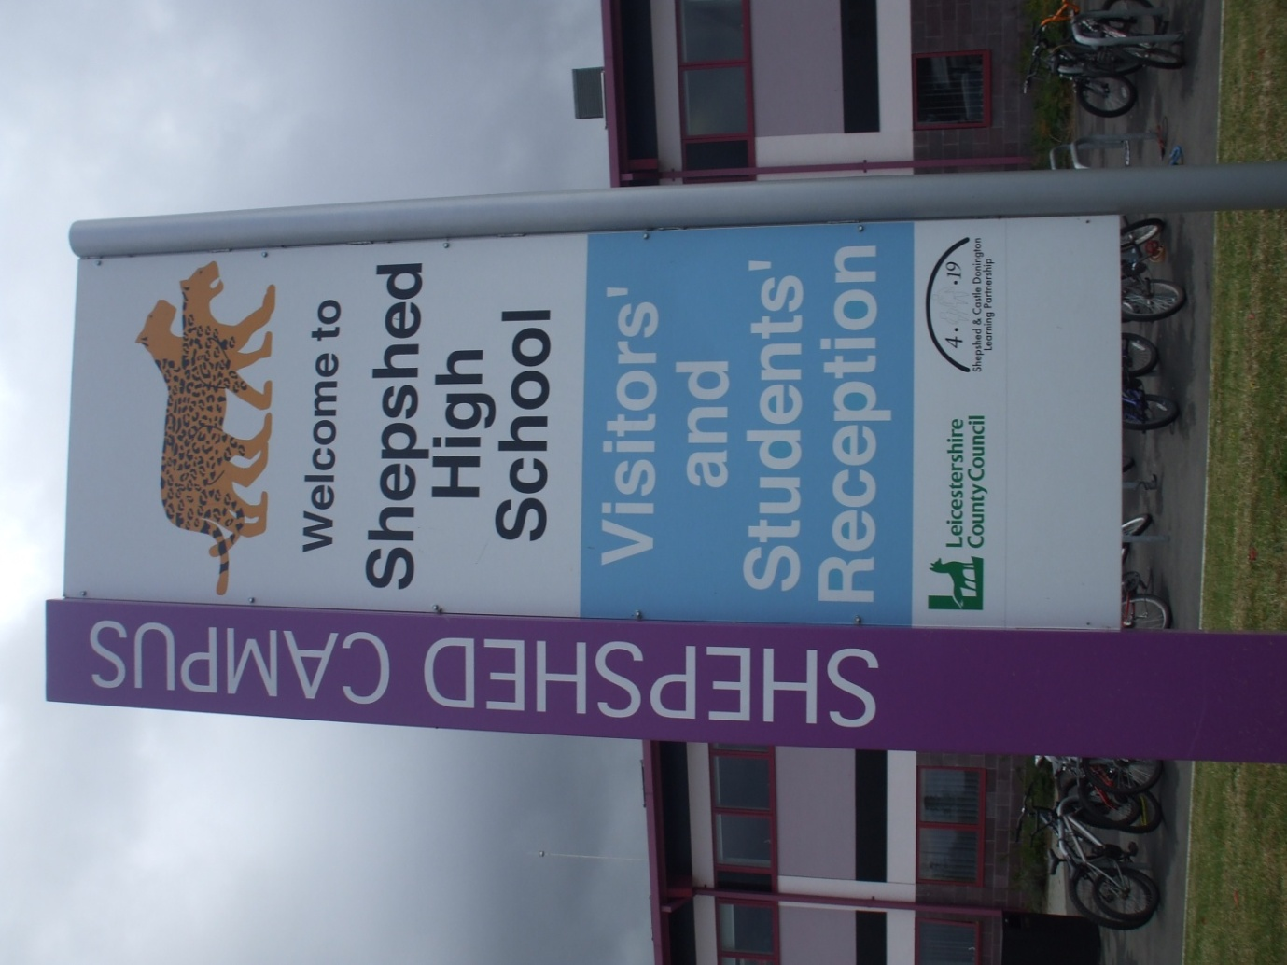
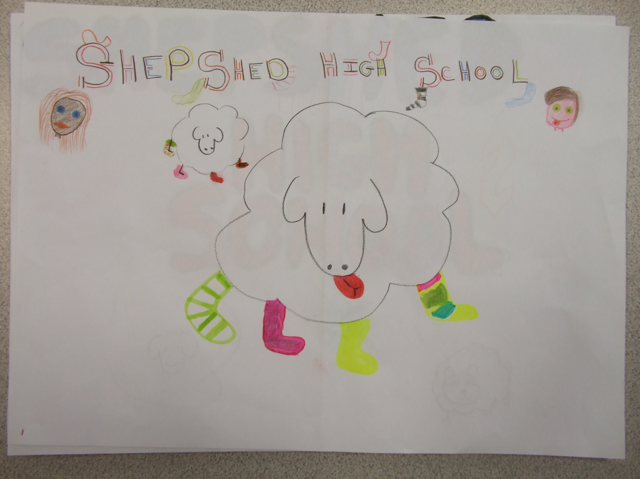

The name Shepshed comes from sheep’s head, which Shepshed used to be called. The reason the sheep is wearing socks is because Shepshed used to be famous for making socks.

