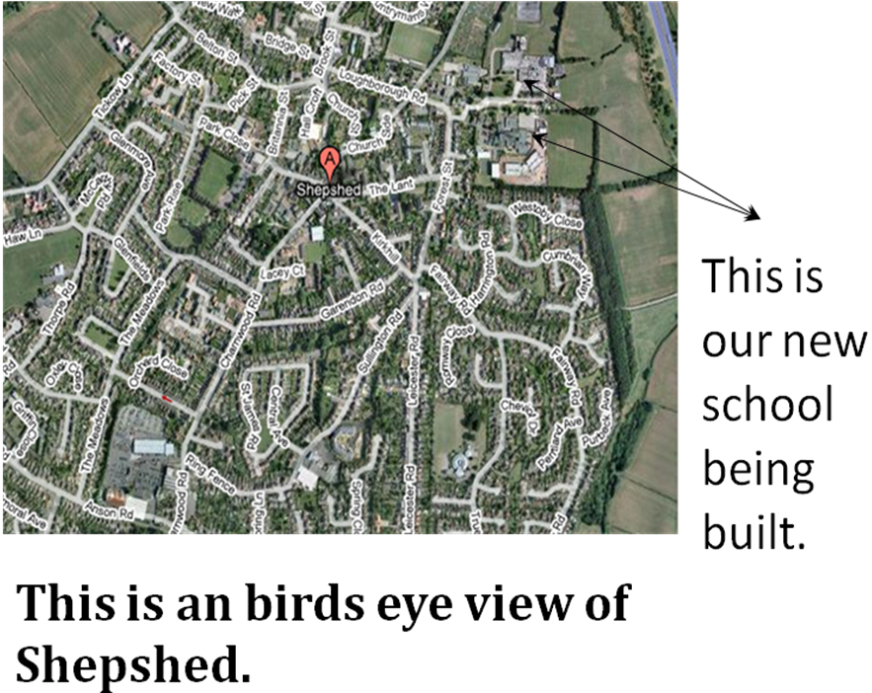
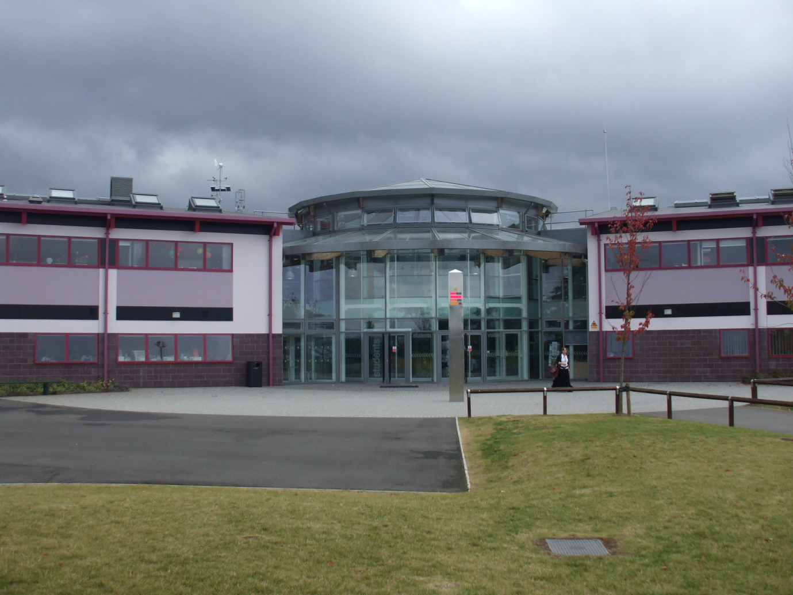
This is the front of our school. It was built in 2007. The entrance is in the middle of the building. The ICT room and the library are also in this part of the building.
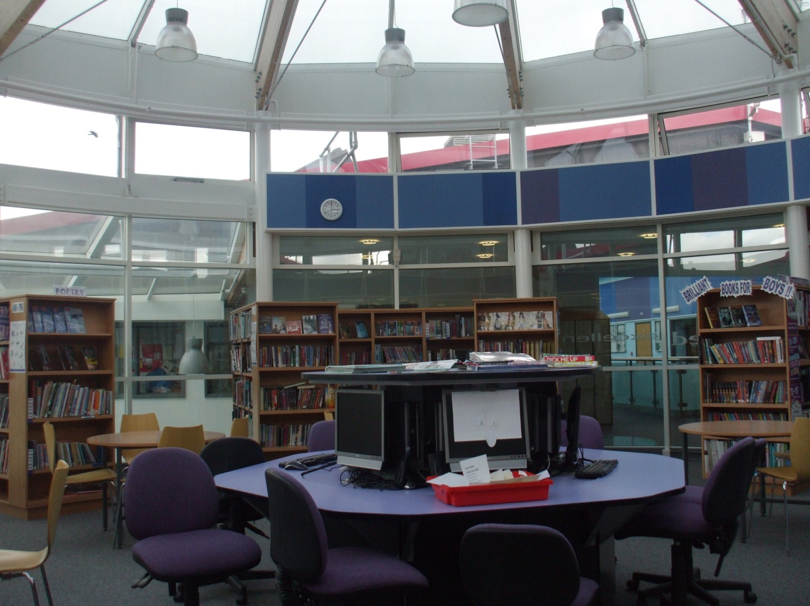
This is a picture of the inside our library.
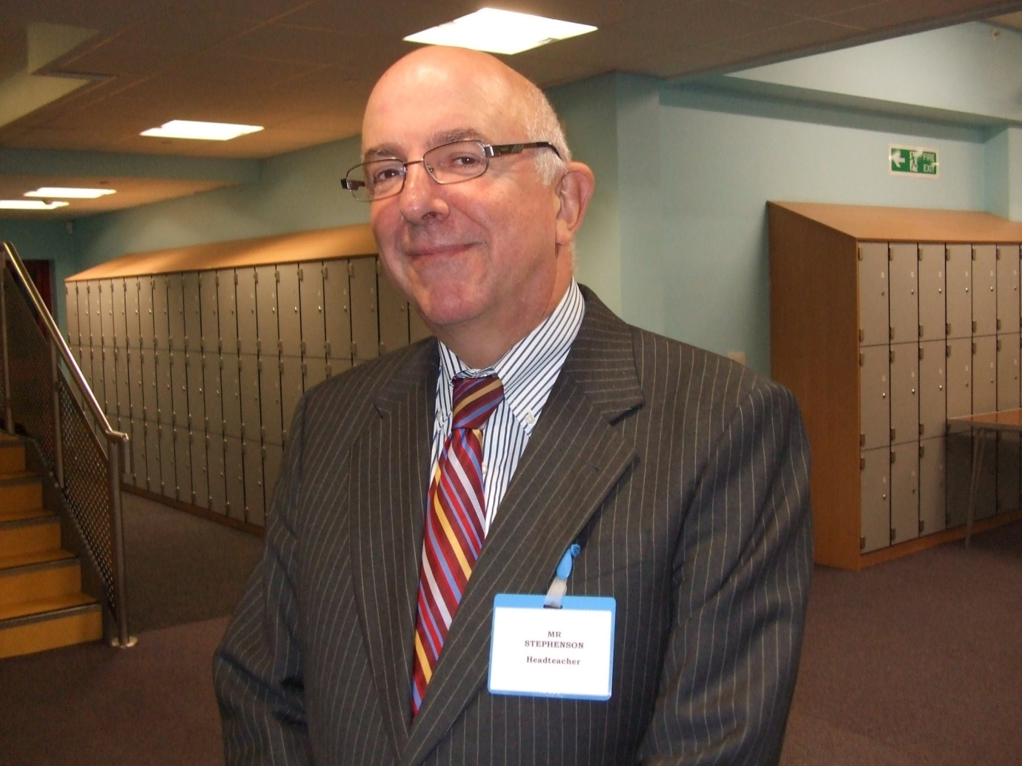
Mr Stevenson is our head teacher.
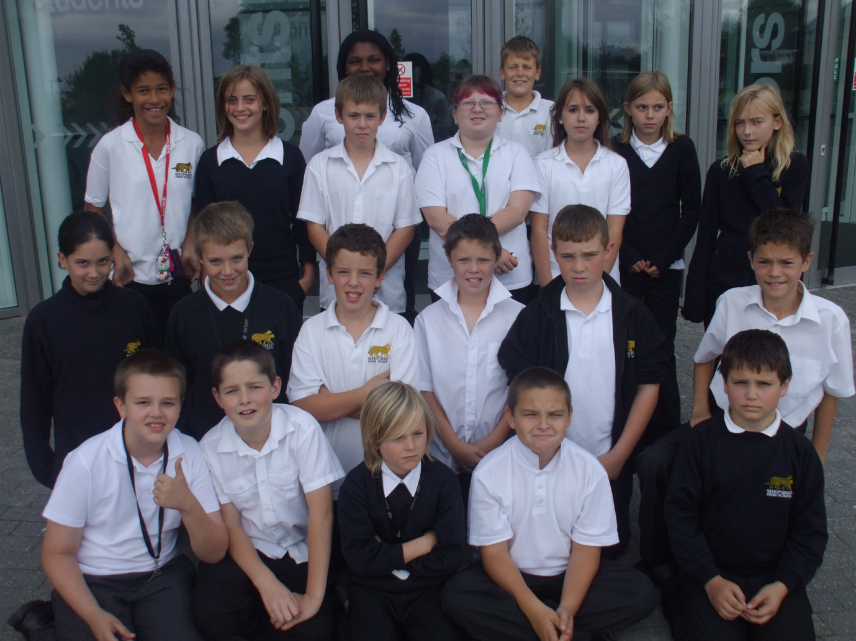

This is our class. We are in Year 7 and we started at Shepshed High School at the start of Year 6.

